Vamos a linea de commando

Se conecta con la subscripcion

az account set --<suscripcion>

Crea grupo myrg_dbservers , asigna localizacion en westus

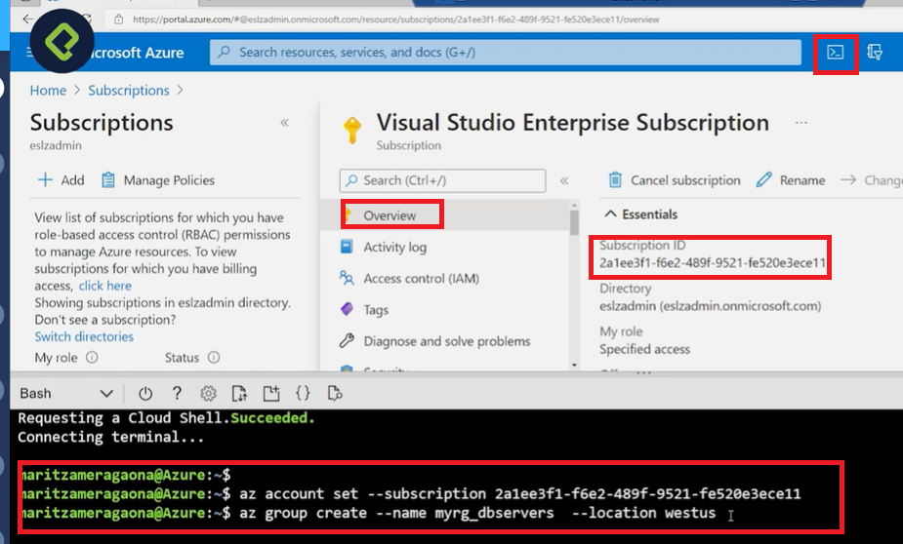

**CREAR DB**

az mariadb server create --resource-group myrg_dbservers --name mydemoserver --location westus --admin-user myadmin --admin-password <server_admin_password> --sku-name GP_Gen5_2 --version 10.2

**ACCESO FIREWALL**

az mariadb server firewall-rule create --resource-group myresourcegroup --server mydemoserver --name AllowMyIP --start-ip-address 192.168.0.1 --end-ip-address 192.168.0.1

**SSL**

az mariadb server update --resource-group myresourcegroup --name mydemoserver --ssl-enforcement Disabled

**CONNECCION INFO**

az mariadb server show --resource-group myresourcegroup --name mydemoserver